`Cthulhu by Gaslight

Savage Worlds conversion with no terror rules.

1986 The Yorkshire Horrors



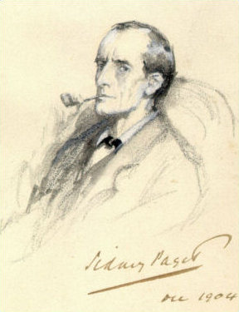This game references the Savage Worlds game system, available from Pinnacle Entertainment Group at www.peginc.com. Savage Worlds and all associated logos and trademarks are copyrights of Pinnacle Entertainment Group. Used with permission. Pinnacle makes no representation or warranty as to the quality, viability, or suitability for purpose of this product.

# Forward

This is a re-work and conversion of the most excellent *Cthulhu by Gaslight[1]* adventure supplied in the 1986 release entitled “The Yorkshire Horrors.” The conversion is into a *Savage Worlds*[2] system and using the setting *Agents of Oblivion*[3]*.* A copy of “The Yorkshire Horrors” is needed to use this conversion. [4]

I had a request from my players to see if we could use some old school items in our campaign and to mix and match some different types of material. I tried some horror without the insanity rules and corruption rules and it went very well. So now we will try something a bit larger.

You will need a copy of Realms of Cthulhu[5] setting for *Savage Worlds* to help with the conversion and running H.P. Lovecraft style horror in a *Savage Worlds* campaign.

Michael R Wild

April-May 2013, Aloha, Oregon

**This document is meant for the Director’s eyes-only.**

# The Hook

The players send the agents into the library at Miskatonic and discover a copy of Doyle’s Sherlock Homes stories that appears to be glowing with arcane power. When they approach it the are transferred to an other alternative reality where they are agents in 1896 working for an agency much like there agency the worked before. All their existing gear is now a “steam-punk” version of the same gear.

The Pattern Used for Mission

The basic pattern used is the same as used for *Agent of Oblivion* one shot missions that often can be played in one sitting except is expanded to a multi-sitting format and is a conversion of an existing *Cthulhu by Gaslight* adventure. The plot is described and how the missions are connected to the plot. The missions contain the somewhat styled format of starting with name of a mission and a briefing for the mission. A text for the players is supplied in italic for the mission that may be read or paraphrased to the players by the Director. This is followed by a write-up on any resource items that are supplied to the agents and the players may then work with the Director to assign resources to their agents (*Agents of Oblivion*, here after called AoO, page 47) for the mission. The mission is then divided into numbered scenes that represent opportunities for the agents to take actions and participate, willingly or unwillingly, in combat. The scenes also have text in italics for the Director to read or paraphrase to the players and list of enemies and allies for combat and a usually a map. Often the Director can use a premade purchased map or draw one for the players to use; exact matching to the supplied map is unnecessary. A list of creatures, “Monsters,” and often specifications of the creatures are supplied or a reference to a “Monster” from *Savage Worlds* rules, here after called SW, may be found in section at the end of the scene. A scene may have an aftermath or the mission that follows it completion and addresses the results of the scene or mission (both positive and negative results) and this section will describe what happens to severally injured agents.

Letters and images are supplied with the scene descriptions to allow the Director to better understand the flow. The director may supply copies to the players at the correct moments.

Note: The author recommends a copy of the Ordnance Survey one-inch map 42 to be purchased and given to the players. It is available for purchase on the Internet and even with shipping is about $9.00 USD from UK. The map is published by Alan Godfrey Maps[6]. The map was published in 1904—it should work fine. The Director can suggest that Mr. Holmes brother Mycroft was able to get an early version in 1896 for the agents.

Weather in April 1886[7]

The historical weather is known for April 1886. Using the historical records, the first two weeks of April were damp and cloudy. The second half of April was unusually warm, sunny, and clear of rain. High pressure is recorded the historical record. It should be in the sixties and dry for the player’s agents as they start in London about mid-April.

There were thunderstorms start on the 28th and for game purposes we will have thunderstorms over Stonehenge for the climatic battle.

# Notes to The Director

The campaign that this was converted to is a *Savage Worlds* game using the *Agents of Oblivion* setting. The rules found in *Realms of Cthulhu* were used to support the conversions. The campaign is set in 1974 but with the agents having all technology available to them in 2013. The Internet is of course not that useful as most records are not available for the 70s. The house rules are not to use insanity or metal anguish or corruption for any H.P Lovecraft.

House rules in use: “Should H.P. Lovecraft like settings be used then both Mystical and Paranormal knowledge can be used. The Director’s replies will be stylized to fit the type of knowledge skill used.” And this: “H.P. Lovecraft styled creatures and events may occur in the game. The agents are prepared for these kinds of horrors in their training. Insanity and shock rules will not be used from other settings; existing SW fear rules will be used. Facing mind-bending and possibly mind-eating eldritch horrors is just a regular day at the office for our agents.”

Another campaign may follow their house rules or align to *Realms of Cthulhu* setting for a more horror-based system.

# Revised Magical System

Again, the Director can use other rules. This section lists a few “house rules” to manage the use of AoO instead of a horror-based system.

The casting of spells from the mythos uses simple rules for this conversion:

1. It is either a Knowledge (Paranormal or Mystical) check to cast a spell based on the mythos. All checks are -2. Only one person/creature is casting a spell and must be identified before checks are rolled.
2. If the caster is a mythos-based caster/creature the caster/creature gets +5 to cast the spell.
3. Assistance may be given to someone casting a spell. This too requires the same check, Knowledge (Paranormal or Mystical), and on success grants a +2 to the roll of the spell caster. Failure to assist grants a +0 to the spell caster’s check and the would-be-assistor becomes fatigue. [8]
4. Chanting can help and for every five Extras chanting there is a +1. The chanting extras will be exhausted after the spell completes.
5. Chanting wildcards add +1 for every three that are chanting. When the spell is completed the Wildcards that were chanting make a Spirit check. On a failed Spirit check the chanting will leave the Wildcard fatigued.
6. Greater spells are very difficult and the checks are -10 harder (total of -12).
7. Incredible spells are nearly impossible to find and successful cast and are at a check of -30 more (total -32).

Failure of checks can have disastrous consequences depending on the spell. Missing a check with rolling two ones is surely a disaster—no Benny’s will save the agents from a backlash. The Director should invent a disaster or one should be obvious as a backlash. For example, the Hounds of Tandalos[9] are often known to catch the scent of a would-be spell caster. Having those horrors start to track the agents would be a very painful backlash.

Learning a spell is usually a long process in the standard horror-based systems. In this story the agents can use any spell they find without the long.

# The Briefing

The agents receive a short briefing in writing.

*Our Miskatonic University agents have contacted the agency with a request to investigate the library of the University. There is a large amount of unexplained arcane energy in the library.*

*The agents are ordered to Arkham to investigate and to take action as needed.*

*Knowledge of the threat and its resolution is restricted to agency personnel.*

*Arkham is a gama gama risk city. Do not approach gama gama deities or artifacts.*

# The Mission Profile

The agents are in the open and should act with discretion and should not be in the press or in trouble with the local officials. The agents should be armed and prepared for a H.P. Lovecraft style threat.

Threat: Is unknown, investigate, determine threat, eliminate.

Parameters: Locals must be kept from knowledge of threat and its resolution.

Supplied equipment: The agents’ travel is to Arkham is covered, as is their stay at their choice of normally priced hotel/motel. As always--normal expenses for travel in the area is covered. In addition agents may receive the following *perks:* cover identity, disguised gear, emergency contact, and one clip of modified rounds (Elder Sign) (works as “magical” attack).

All other gear is available except air strike.

# Scene 01: The Library

The library is at the University[10] and is the trap that ends the agents into the alternative reality in London 1896. The Director can use other means to get the agents to 1896.

*The university is pleasant enough and the library new. The problem appears to be in the rare book room and this is not really that safe of a place in Arkham!*

*You are met on the steps of the university library by the head librarian, a man with gray hair in a black suit that is a few decades out-of-style and glasses. “I am Fred Rogers and head librarian,” he says as you smile at the name; he seems to ignore you smile and goes on. “Come this way,” he says in a voice that is a bit too quiet but clear. You enter the library, notice a sign that says “closed,” and head up stairs to the second floor. You follow Mr. Rogers through a maze of books and reading tables. All look strange without students. He comes to a strong wooden door and unlocks the door with a key from his pocket. “It is in the rare book section,” he says. “Apparently a copy of one of Conan Doyle’s books is glowing and scaring the librarians,” he says with the annoyance. “Likely a student has gotten some glow paint again,” he explains and raises an eyebrow. “Last year all the Tolkien books glowed elf writing,” he says with some frustration. “The book that is glowing is a signed copy with some strange symbols drawn in it by Sir Doyle,” he informs you. “It seemed a good fit for our collection,” he says to nobody.*

*“Here we are, please be careful,” he says as he waves you in. Books are in glass cases and appear to be first editions and signed copies of well-known books. “This is the rare books not the arcane rare books and we never have problems here,” he says knowingly to the agents. You spot a glow and an old copy of Sherlock Homes is glowing. The librarian is staying out of the room, seems he has some experience with strange texts and is letting the agents deal with the luminous book. You approach the book and agree with Mr. Rogers that it looks like some prank—then the book moves.*

*Before you can think the book spins around, books on the shelf are thrown across the floor, and it opens. There is a flash of light and you have a moment to think, “In Arkham even a mystery novel is a dangerous book!”*

# Scene 02: 1896 London

The agents are now translated to steam-punk and an alternative reality in which they join forces with Sherlock Homes to stop Moriarty for carrying out is planned revenge.

The agents are transformed into 1895 agents with steam-punk version of any technology that would not normally appear in 1895. A laptop is now made up a fine gears and run by difference engine with the screen looking much like an etch-a-sketch. Automatic weapons now look cruder but still have the same statistics. The clothing and appearance of the agents is changed to match the period. Clothing matches closer to the period with the sloppy looking expensive clothing of the current styles now replaced by hand-made wools and silks of a more formal nature of Victorian England. The Internet is not available even with steam-punk information; libraries are available. Phones and cell phones are steam-punk and they sound a bit odd as tiny gears run tiny motors to run the computing to make the sound for the phones. Any skill that can map to a more usable 1895 setting is automatically translated. Driving can be riding and/or driving a carriage. Computer skills become investigation instead. The players may temporary change them as they wish. Of course that exchange can only be done once.

This scene corresponds to pages 1-4 in the original adventure. Maps are supplied from later pages. The “packet” sent from Mr. Holmes contains all the information he can supply to the agents ahead of time. The author also supplied a reprint of a map from 1904 in the packet sent by Sherlock.

*The agents find themselves in 1895 and in London. Their gear has been transformed into a steam-punk version of their original gear. The agents are aware that the Internet is not available in 1895 as none of the records are automated and some items have become quite odd. For example, a laptop computer is now an amazing mechanical miniaturization of Babbage’s famous engine using a screen much like an etch-a-sketch. It is still a laptop. Automatic weapons are cruder looking but are the same functionally. Clothing and your knowledge now fits the period; your general knowledge covers 1896, England. It is April and the weather is strangely pleasant and warm for London in April.*

*As you and your group stand by Nelson’s column in Trafalgar Square a man approaches for the Agency and hand you a package of paper and says, “Gamma threat has been detected and the Agency would like you to assist Mr. Homes.”*

*The packet contains a three hundred pounds of money for travel, some letters, maps of the local area and a mansion, and tickets from King’s Cross Station to Northallerton in Yorkshire. You flag a four wheeler and head to the train station.*

The scene ends with the players looking at the material as they get ride to the train station.

Short letter from the Agency:

The agents are ordered to assist Mr. Homes to investigate his brother’s case in Yorkshire and to take action as needed.

The Agency believes that darker are forces are moving against Mr. Holmes, some which are out-worldly. The agents are to support Mr. Holmes against an out-worldly incursion.

Supplied equipment: The agents’ travel is to Yorkshire is supplied and Mr. Holmes has supplied the agents with information and places to stay. In addition agents may receive the following perks: cover identity, disguised gear, emergency contact, and one clip of modified rounds (Magic) (makes the bullets work as a “magical” attack).

All other gear is available except invasion and naval bombardment.

Letter for the players from Mr. Holmes:

Sir;

I feel assured that you know of my name and profession and, perhaps, have read one or two of my more successful cases popularized by John H. Watson, M.D. Without further disclaimer, it is with a keen sense of irony that I find myself writing to your detective society as one who is in need of assistance.

I am currently involved in a case vital to the Crown. It is perhaps not too bold to state that the fate of the Empire hands in the balance. Hence, despite my intimate interest in another case, I beg you to undertake it in my stead. The particulars follow.

My oldest brother, Sherrinford, is accused of the murder of one of his servants. It is certain that he cannot actually committed the crime, and I request that you and your associates please travel to the Holmes family estate, Mycroft Manor, in the North Riding of Yorkshire, and clear Sherrinford of the charges. Thanks to our brother Mycroft (a minor government official, but not devoid of influence) and myself, Sherrinford has thus far remained free. I desire, however, that Sherrinford’s name be cleared, as my brother is agitated by the incident and his reputation must be restored.

In strict confidence, do not trust the constabulary to hand the situation properly. Without intervention, the local bunglers will eventually convict Sherrinford merly to close their books on the case.

I have been given to understand, from mutual acquaintances, that you are familiar with my methods and have, in the past, been known to practice them yourselves. I am flattered. It also gives me confidence in your abilities.

I regret that I cannot provide you with more information. I myself have not visited the site, and it is a capital mistake, most destructive to the reasoning faculties, to theorize before obtaining the facts. These facts are only available in Yorkshire.

The nature of my present case makes it impossible for you to contact me during the investigation. However, you may wire my brother Mycroft at the Foreign Office, or at his club, the Diogenes in Pall Mall.

Sincerely,

**S. Holmes**

Maps for players of the area supplied by Mr. Homes:

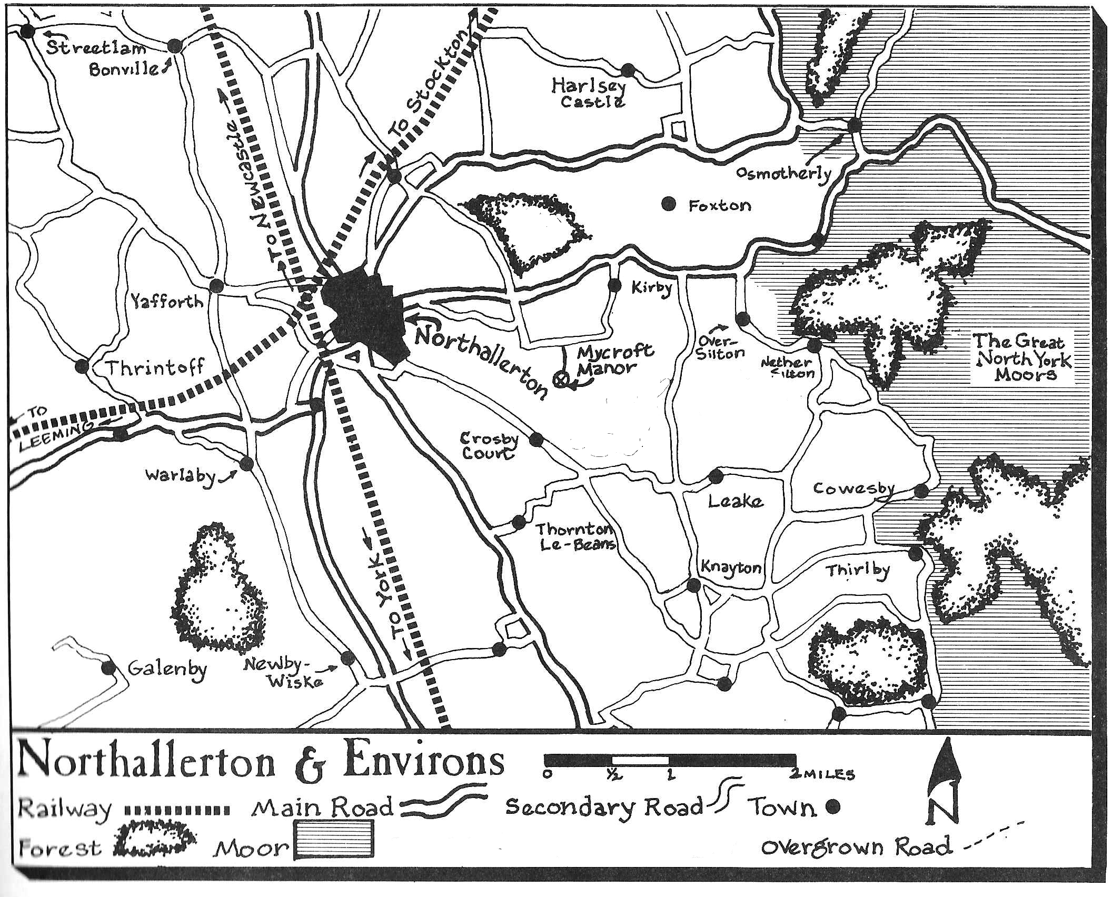[11]

Map of mansion for players:

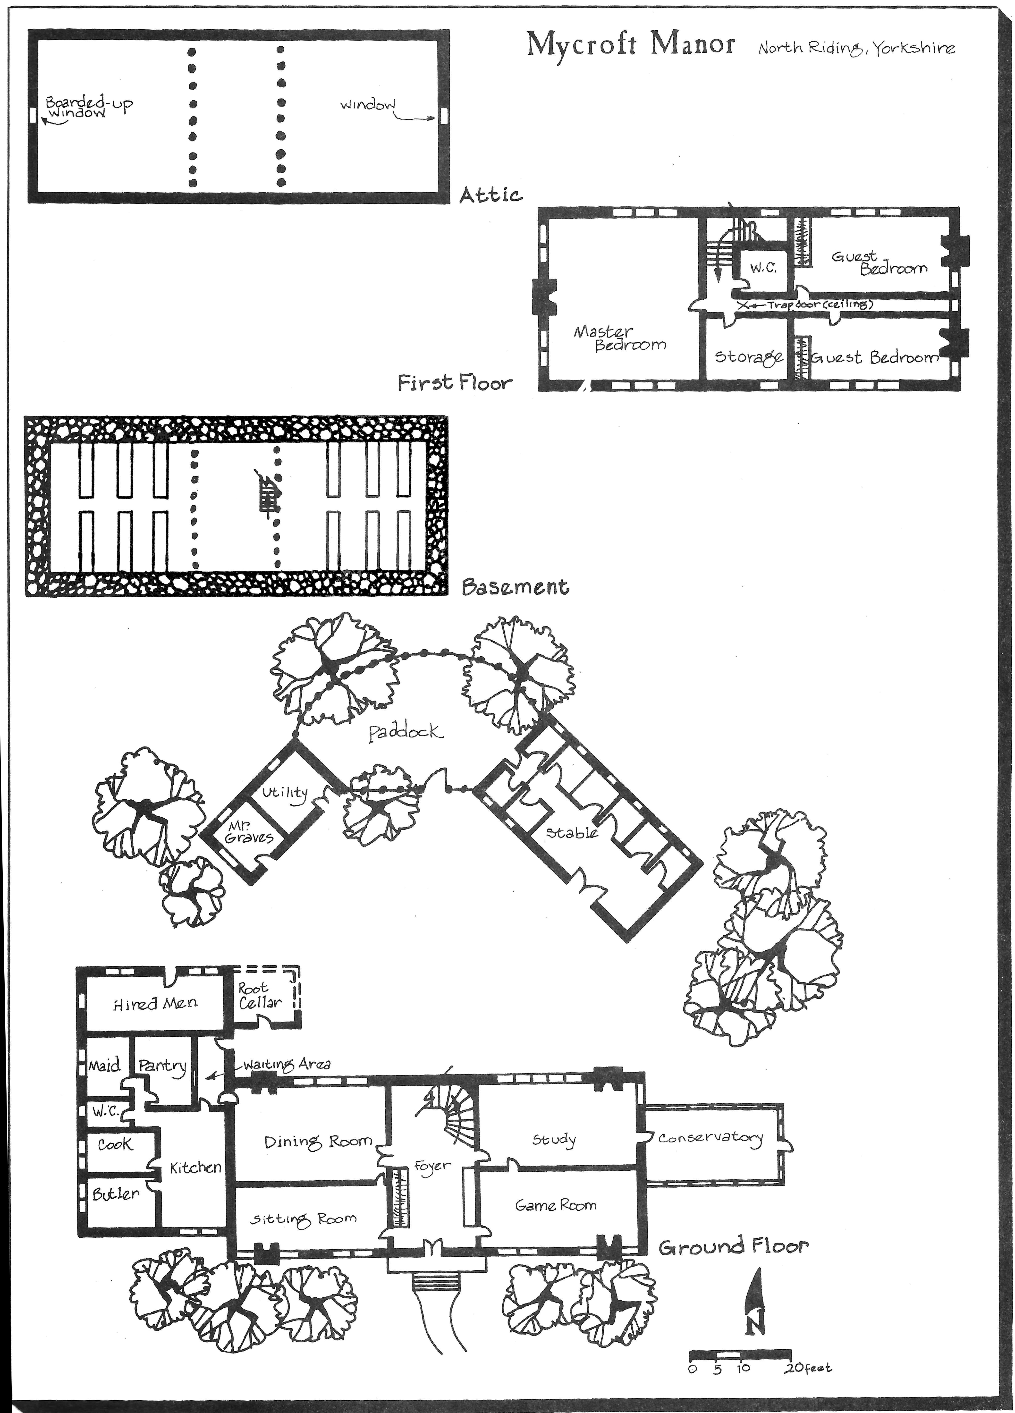[12]

# Scene 03: Train to North Riding, Northallerton

The agents arrive at the train station and review the packet of materials while travelling.

The Director should serve tea and crumpets while the players review the material, discuss it, and ask some questions that general knowledge should be able to answer. This represents the time on the train.

Image of King’s Cross Station[13] for players:

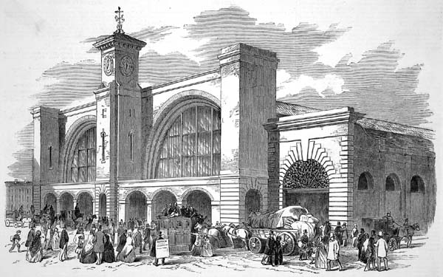

*You find your tickets in the packets, first class to North Riding village of Northallerton, and soon find your train is the tall train station of stone and steel at King’s Cross. You may find a comfortable car and relax and look at the materials sent to you by Mr. Holmes. It is a slow travel day so there is a car and there is no need to share the car with anyone. A cart comes by with tea service.*

*The train is a newer steam coal train and it moves fast and delivers the team to an open train station in Norhtallerton.*

It is tempting to add an attack to the train ride. The storyline so far is that Sherlock Holmes surprises and frustrates Prof. Moriarty’s plans by sending a team unknown to him and his organization. Until the team appears at Mycroft Manor they are unknown. The agents are a surprise to Prof. Moriarty and he can find no information on them or their agency; he knows anyone that would be good so he assumes they are bunglers and an attempt to distract him.

This scene corresponds to page 4 in the original adventure.

# Scene 04: Northallerton

Supplied with cash, drawings, maps, and letters the agents arrive in Northallerton. This is a small town with a nice brick church, a few small factories, hospital, and a few pubs. It is still England, but quite north and not far from the coast. The land is farmed and flat between the hills. The west contains the Pennine Hills—the highlands. East are more hills, the Hambelton Hills and Cleveland hills. A great moor lies further to the east.

*You are meet by an older but healthy looking man who loads up your luggage without help and drives an open carriage. His name is just given as Graves and he is a servant. He seems not to be unfriendly, just very reserved. The roads are more like lanes and soon you are driving through farms and seeing a lot of countryside.*

Graves is the groundskeeper at Mycroft Manor and he meets the agents at the train station with a large carriage and loads their luggage and whatnot onto the back and top of the carriage. He drives them to Mycroft Manor and they should arrive there by late afternoon.

If asked about the police or local officials, Graves will inform the agents that such folks as they have in North Riding are at the manor now. Until the agents meet with Sherrinford Graves will be very reserve with them.

This scene corresponds to pages 5-6 in the original adventure.

Information on North Riding of Yorkshire for players:



Arms of North Riding of Yorkshire[14]

Notes on the local area: The area is rural and the roads and layout predate the Romans. The land is ancient and a great moor lies to the east. The area is one of the few loyalist sections of Yorkshire.

The area was once owned by a the family and all the farms were tenants. This has changed and much of the land is owned and farmed by smaller farmers. The cities are small and have no modern industry.

The land is flat between the hills and very fertile. Northallerton is a market town.

Picture of the town:

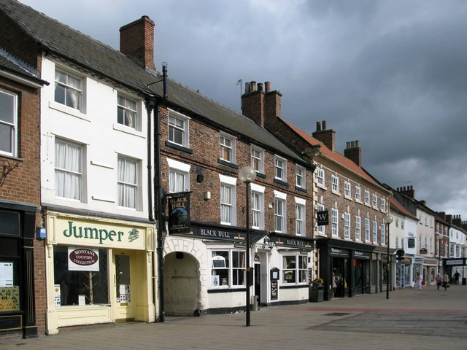[15]

# Scene 05: Meet Police

When the agents reach the mansion they meet the police as they are leaving.

*As you pull up to the Mycroft Manor, two men leave the house. Graves looks a bit grim. One man is obviously a local and the other a city dressed man. The local man, obvious a constable, says “Here na, who are you, then?” in a broad Yorkshire accent.*

This is from pages 6-7 and the Director will need to be prepared to read from those pages.

If the Agents identify themselves as agents of Mr. Holmes and here to help they will be treated a neutral by the officers. If the agents make a Persuasion check to get more information or to talk to the office Gregson will be disruptive, but Constable Danvers Culverston will be willing to meet them at his office. If the agents are not forth coming or fabricate a story, they are already known by description to Gregson as agents to Mr. Holmes. He will call them out on their lie and Culverston will then treat them as just thugs and to be ignored.

Graves will argue with Gregson about the innocence of Sherrinford Holmes. He will be very strong in his arguments that Gregson is just trying to pin this on anyone. The argument will get quite heated. Graves will defend Sherrinford’s honor.

# Scene 06: Meet Sherrinford

After meeting the police at the mansion the meet Sherrinford Holmes.

Graves states your names to a very proper and older man and butler, Jeves. Graves will see to your items and wraps. “Meet Mr. Holmes please and find the proper,” Graves tells you. You follow Jeves to the study, a room of Victorian hunting scenes with shotguns on the walls, to wait for Sherrinford Holmes.

*A few moments later a large man dressed in country cloths but all of the finest quality appears before you. “Welcome to Mycroft Manor,” he says as he steps to shake each person’s hand and to bow to any ladies. He offers a glass of brandy to each and looks relieved. “My brother sent me a telegram that you were coming and that you are offer some unique viewpoints and skills,” he says as he raises an eyebrow. He shakes his head, “No non-sense please.”*

This is from pages 6-7 and the Director will need to be prepared to read from those pages.

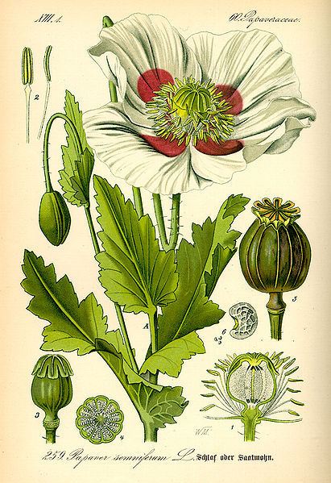The text of Sherrinford’s statement is on pages 4-5. Copied and remove last paragraph and give to the players.

# Scene 07: Mycroft Manor

This is from pages 7-12 and the Director will need to be prepared to read from those pages.

Additions or changes are listed below, as are all the persons involved. SW is a bit less specific on some checks and so some items are combined.

## Sherrinford Holmes’ Study

A Notice roll finds the chalk and the rat hole. A raise and the chalk patterns are understood to be the remains of some kind of mythos spell.

See page 7.

## Conservatory/Greenhouse

If the agents are there at night and make a Notice check the will head faint scratching sounds and on a raise the agent makes out tiny voices like miniature human voices.

Hidden in the plants are some rat holes but unless a check is made to not damage the plants Sherrinford and Graves will be upset about the damage; they will just be unhappy and take no action. If the agents look for it, there are a few notorious white poppy plants[16]. If asked, Sherrinford and Graves are surprised and guess that some seeds must have come in some other plants in error.

See pages 7-8.

## Game Room

A collection of painted tin soldiers is found here in Napoleonic period dress set on a small table in lines as if on review. One section of the floor is painted as a map of Waterloo. There is a small set of rules from Robert Louis Stevenson that appear to be hand typed in a small drawer in the table. The pool table is also there. The chairs are over part of the map. A few marks on the floor suggest that the furniture is moved to play a game of Waterloo. There is a gate under the pool table that will be unnoticed unless the agents check under the table or say the carefully search the table.

With a Notice check and the agents spot that a rat or something has chewed some of the French tin soldiers and that the general is missing. The British and allies are intact and undamaged.

See page 8.

## Foyer

A Notice check spots a tiny rat hole that is hidden by a small loose board almost like a hidden door.

See page 8.

## Pantry

The curry is obviously drugged. It is very hard to detect the drug in the spice but the easy test of feeding some to a dog (recalling the movie) and seeing dog immediately sleeping should get the point across to the agents. Checks should not be needed for this.

See page 8.

## Kitchen

There are two Rat-Things in the root cellar and they are well hidden. They will attack if found and if the agents are searching and obviously enemies. If slain the Rat-Thing bodies will just look like huge rats; the human-like face will fade away and turn into a huge rat only face.

There is a rat hole in the kitchen again hidden like a secret door behind a wooden board. This will take a Notice check and on a raise the agents hear little feet in the wall that leads them to the root cellar.

See pages 8-9.

## Jever’s Room

The mirror is a common knowledge check that the agents understand that it is just a mirror. If Jever’s is asked about the mirror he will reply that it is old and a family heirloom. If asked about the glow, he will smile, and tell them it is a diamond dust mirror and not “magic” while shaking his head.

See page 9.

## Lucinda’s Room

The pendent is used to mark sacrifices to mythos gods and creatures. It is made of some strange stone that has been gilded with gold. A Knowledge check, either mystical or paranormal, will inform an agent of the use of the necklace. Lucinda will not willing give it up.

See page 9.

## The Hired Men’s Room

The locked footlocker can be opened by a Lockpicking check. If the agents check they might avoid a magical trap on the Stark’s footlocker, a Notice check with a rise or a Knowledge (Mystical/Paranormal/etc) check to know there is a trap. A contest of wills can be used to remove the arcane alarm against Stark (d10 plus wild die). The arcane alarm summons four Rat-Things. They will come from the closet. The gate is in the closet. Ignore the set-the-clothing-on-fire in the closet, as that is just silly. No fire.

The Sussex Manuscript is replaced with a confused translation of Necronomicon. It is written in miniature handwriting needing a magnifying glass to read, also on the footlocker. The spell Curse of the Rat-Thing is included in the manuscript. It appears to any reader that tiny hands transcribed the original by memory. A Rat-Thing made the manuscript by sneaking into a library through a rat hole and reading a page and then trying to remember it and writing down. It did this for years one page at a time.

See page 9.

## Utility Building

The dynamite is well hidden but will be found with a Notice check. It will take a Persuasion check to let the agents have dynamite from Graves. If the agents are unclear about their reasons then the check is uncooperative otherwise it starts a neutral.

See pages 9 and 10.

## Master Bedroom

Notice check to spot rat hole. Again it looks like a miniature door.

See page 11 in original.

## Attic

It just takes time to get to the attic and can’t be done in stealth. It is a Notice check to see the disturbed dust and tiny hands tracks and not rat tracks.

The gate can be burned and the smoke will form an image of the last person that passed through the gate, Moriarty in this case. The agents need to make a check to determine how to remove the gate marks and to get the image, Knowledge (Mystical/Paranormal).

See pages 11-12 in original.

## Basement

Unless the agents are just getting some wine, the Rat-Things will be watching them and will attack them. There is one Rat-Thing for each agent and half that many will appear two round later.

The secret passage is walled-up and only a rat hole hints at it. As the text describes the rat hole has a breeze moving through it hinting at a larger tunnel behind it. The tunnel is known to Graves a rumor of years ago. He will be surprised to learn that it really exists.

See page 12 in original.

## Rat-Things in house

There are the rat-things found in the root cellar and the house[17].

**Attributes:** Agility d12+1, Smarts d6, Spirit d6, Strength d4, Vigor d6

**Skills:** Fighting d6, Notice d6, Stealth d12, Knowledge (Mythical)

**Charisma:** --; **Pace:** 6; **Parry** 5; **Toughness** 3

**Languages:**English

**Special Abilities**

* **Bite:** d4+1
* **Cling:** Once a Rat-Thing bites, it does it normal damage and continues to gnaw on its victim. It automatically bites until pulled off (a strength contest).
* **Skitter:** Ranged attacks are -2; the small size and skitter movement makes the Rat-Things hard to hit with ranged attacks.
* **Small and Fast:** If aware of its attacker the attacker is at -2 for any attacks.
* **Spell Shrivel**—the victim shrivels up and turns black if the victim vales a contest of wills and takes a wound and a raise the victim takes two wounds (see alternative rules of casting spells above: Revised Magical System).

## Sherrinford Holmes (Wildcard)

See page 12 in original.

**Attributes:** Agility d6, Smarts d10, Spirit d8, Strength d8, Vigor d10

**Skills:** Driving (Carriage) d6, Fighting d8, Healing d6, Notice d6, Knowledge (Accounting) d6, Knowledge (Art) d8, Knowledge (Astronomy) d4, Knowledge (Botany) d4, Knowledge (History) d4, Knowledge (Law) d4, Knowledge (Zoology) d4, Persuasion d6, Riding d10, Shooting d8, Stealth d6, Track d8

**Charisma:** +2; **Pace:** 6; **Parry** 6; **Toughness** 8

**Hindrance:** Code of Honor, Heroic (women)

**Edges:** Brave, Attractive

**Languages:**English, French, German, Latin, Greek (written), Italian (spoken)

**Gear & Equipment:**

Shotgun, double barrel (12g): Range: 12/24/48, Damage: 1-3d6, ROF: 1-2, Shots: 2.

Riding crop: d8.

+2 versus Fear

## Graves

See pages 13-14 in original.

**Attributes:** Agility d6, Smarts d8, Spirit d8, Strength d8, Vigor d6

**Skills:** Driving (Carriage) d8, Demolitions d6[18], Fighting d8, Healing d8, Notice d6, Knowledge (Botany) d6, Knowledge (Gardening) d8, Knowledge (Horse Care) d10, Knowledge (Mystical) d4, Knowledge (Zoology) d6, Persuasion d6, Riding d6, Shooting d8, Stealth d6, Repair d8

**Charisma:** --; **Pace:** 6; **Parry** 6; **Toughness** 5

**Hindrance:** --

**Edges:** --

**Languages:**English

**Gear & Equipment:**

Shotgun, double barrel (12g): Range: 12/24/48, Damage: 1-3d6, ROF: 1-2, Shots: 2.

Club: d8.

Axe: d8+d6.

## Jevers

See page 14 in original.

**Attributes:** Agility d6, Smarts d8, Spirit d8, Strength d6, Vigor d8

**Skills:** Driving (Carriage) d6, Fighting d6, Healing d8, Notice d6, Knowledge (Accounting) d6, Knowledge (Etiquette) d12+1, Knowledge (History) d6, Knowledge (Law) d6, Persuasion d4, Riding d6, Shooting d4, Stealth d6

**Charisma:** --; **Pace:** 6; **Parry** 5; **Toughness** 6

**Hindrance:** --

**Edges:** --

**Languages:**English, Greek (read), Latin

**Gear & Equipment:**

Knife: d6+d4.

## Mrs. Hooper

See page 14 in original.

**Attributes:** Agility d6, Smarts d8, Spirit d6, Strength d6, Vigor d8

**Skills:** Fighting d4, Healing d8, Notice d4, Knowledge (Cooking) d12, Knowledge (Occult) d8, Knowledge (Mystical) d4, Persuasion d4, Streetwise d4

**Charisma:** --; **Pace:** 6; **Parry** 4; **Toughness** 6

**Hindrance:** --

**Edges:** --

**Languages:**English

**Gear & Equipment:**

Knife: d4+d4.

Axe: d4+d6.

## Lucinda Jones

See pages 14-15 in original.

**Attributes:** Agility d8, Smarts d6, Spirit d6, Strength d6, Vigor d6

**Skills:** Driving (Carriage) d6, Fighting d4, Healing d8, Notice d4, Knowledge (Cooking) d6, Knowledge (Housekeeping) d10, Knowledge (Mystical) d4, Persuasion d4, Riding d4, Streetwise d4

**Charisma:** +2; **Pace:** 6; **Parry** 4; **Toughness** 6

**Hindrance:** --

**Edges:** Attractive

**Languages:**English

**Gear & Equipment:**

--

## W.W. Stark (Wildcard)

See pages 15-16 in original.

**Attributes:** Agility d6, Smarts d10, Spirit d8, Strength d8, Vigor d10

**Skills:** Driving (Boat) d8, Fighting d8, Notice d6+2, Knowledge (Astronomy) d4, Knowledge (Botany) d4, Knowledge (Nautical) d8, Knowledge (Mystical) d8+2, Knowledge (Occult) d10, Knowledge (Pharmacy) d6, Knowledge (Psychology) d6+2, Persuasion d10, Shooting d6, Stealth d6, Throw d8

**Charisma:** +2; **Pace:** 6; **Parry** 6; **Toughness** 8

**Hindrance:** Delusional

**Edges:** Alertness, Brawny, Charismatic, Command, Followers, Mythos Based Caster, Scholar

**Languages:**English, Samoan

**Gear & Equipment:**

Colt 45 US Army: Range: 12/24/48, Damage: 2d6+1, ROF: 1, Shots: 6.

Club: d8.

Knife: d6+d4.

+1 followers to recover from Shaken.

+2 spell casing

Spells are listed on page 15. He can also put an arcane alarm that summons Rat-Things when tripped.

## The Hired Men

See pages 16-17 in original.

Revised to be martial artists. A knowledge check for mystical will allow the agents to notice the men are a bit fish-like. They have taint of Deep Ones. If they poison an agent that moves in with them, they will use a lethal poison that is -0 for a Vigor check[19].

**Attributes:** Agility d6, Smarts d6, Spirit d8, Strength d8, Vigor d8

**Skills:** Fighting d8, Notice d4, Shooting d4

**Charisma:** --; **Pace:** 6; **Parry** 5; **Toughness** 7

**Hindrance:** Delusional

**Edges:** Brawny, Brawler, Combat Reflexes, Martial Artist

**Languages:**English

**Gear & Equipment:**

Kick: 1d8+1d4+2

Knife: d4+d4.

+3 to recover from Shaken (+2 if not in sight of W.W. Stark).

# Scene 08: Workingmen

If one of the agents sleeps with the working then this scene occurs. If the agent tries to play at being one of the workingmen then there is more to do in this area. It will have to be a male in this time period.

See pages 16-17 in original.

*The room is clean and there is a spare bed; the bed was Fischbein’s until his murder. The men are all strong and well a bit ugly with largest eyes and a funny smell. They are surprised to when they meet the agent. “Who be ye,” asks Blackie. The men are very interested in your answer.*

*Later the men awake the agent. “Ye must drink to be with us,” says one of them men named Lucas. They have a bottle and glasses.*

If the agent refuses to share a drink, they will beat him and force him. If he manages to shaken two of the men they will stop. The attacks are non-lethal. If the agents drinks, it is cheap whiskey, then men are happy and welcome the agent. If the agent does not drink they will be unfriendly to the agent assuming he is a spy.

W.W. Stark will assign lonely work to the agent. There are lots of logs to split and sawed for firewood. There is lots of weeding and racking that need to be done. The agent will be treated well as long as his association with the other agents is not detected or obvious.

If W.W. Stark needs an “accident” for the agent he will go with the old fashioned drop a tree on agent. The agent will be racking and then a large tree will come down on them. The agent must make an Agility check to avoid taking serious damage. If the agent makes a Notice check, sees that the tree is coming down, then he gets +2 to the Agility check. Being hit by a falling tree is like being shot by a shotgun in the author’s think so that is 3d6 damage. Of course W.W. Stark will rush out to help the agent and apologize that they were not expecting the tree to comedown so soon. “It was rotten and fell when we laid an axe to it,” he says as explanation.

If the agent does not drink with the men they will result to poison to escape later. They will attempt to slip poison into the agent’s food. A Notice check will detect that the men are waiting for the agent to eat. If the agent refuses the men jump the agent and knock him out and leave him alive and tied-up in his bed.

# Scene 09: Surrounding Areas (No combat)

See page 17-18

## Transportation

The agents may borrow a horse if they have ride skill and scout out the local area. Horse and buggy is also available for anyone without training.

See page 8.

## Tenant Farms

The agents are considered outsiders and must make a check to get information. Streetwise and Persuasion may get more information.

“The squire is a good man from a good family.”

“The troubles started when a good squire hires from outside.”

“My grandfather’s grandfather taught us to always remember that this land is old and holds secrets before the Romans.”

On a raise:

“Trouble really started long ago with the church, the Roman Catholic church built over ruins, and now the home of devils!”

“Old Eban has become protective of his trees. He will shoot anyone that comes near. Old Eban knows something I bet, but it is near impossible to the near him.”

# Scene 10: Standing Stones

If the agents track or follow W.W. Stark at night he heads out to these stones. He will be seen there talking to some spirits in the air. If the agents will be spotted in a few minutes and attacked by two Things.

If the agents track W.W. Stark in the day and visit the stones they can detect the presence of magic and the fact the stones are very old with the obvious checks.

See pages 17-18.

## Things[20]

Flying winged giant serpent like creatures that have extra tentacles popping in and out of their sides.

**Attributes:** Agility d6, Smarts d4, Spirit d6, Strength d12+2, Vigor d12+2

**Skills:** Fighting d6, Notice d4

**Charisma:** --; **Pace:** 8; **Parry** 5; **Toughness** 9

**Languages:**English

**Special Abilities**

* **Bite:** d12+d8+2
* **Armor +1:** Extra thick skin

# Scene 11: Old Eban

There is a beaten path into the forest. A new sign, “Stay away or be shot”, has been painted on a rock on the path. Old Eban will miss on the first shot. He remembers that he could be hanged for just shooting folks. The agents can try to convince him from a distance that they are not an enemy but that is at -4 for the distance and he is most unfriendly for another -2 for a total of -6.

## Old Eban (Wildcard)

See pages 18-19 in original.

**Attributes:** Agility d6, Smarts d10, Spirit d12, Strength d6, Vigor d8

**Skills:** Fighting d12, Healing d10, Notice d6, Knowledge (Botany) d4, Knowledge (Chemistry) d4, Knowledge (Mystical) d6, Knowledge (Occult) d10, Knowledge (Pharmacy) d6, Knowledge (Psychology) d6+2, Persuasion d10, Shooting d8, Stealth d6, Throw d8

**Charisma:** +2; **Pace:** 8; **Parry** 6; **Toughness** 6

**Hindrance:** Delusional

**Edges:** Charismatic, Mythos Based Caster, Scholar

**Extras:** He commands any Dark Young that he sees. They will always obey him and ignore anyone else even if bound. He can also talk to trees and they will give him information about who is in the area and what they are doing.

**Languages:**English, Gaelic, Latin

**Gear & Equipment:**

Shotgun, double barrel (12g): Range: 12/24/48, Damage: 1-3d6, ROF: 1-2, Shots: 2.

Knife: d6+d4.

Spells are listed on page 18.

# Scene 12: Northallerton Constabulary

The agents will either be invited or not. If not they will be ignored and asked to leave. A Persuasion check will be needed to get access to any information.

The agents, assuming they are allowed, will recognize the dagger as magical on a Knowledge (Mystical/Paranormal/etc) check. If they see the ring they may again, after a check again, know it to be a ring of a tainted human related to Deep Ones. If asked about the body of Fischbein the agents are given a letter of introduction to Doctor Sacker.

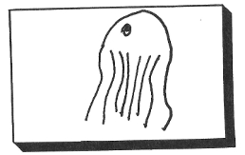Dr. Sacker is a friendly man and role playing him should be talking about how the agents should eat better and get more rest and so on. He will get to findings.

*The doctor recalls for the agents that “Fischbein was cut up and then had one fatal blow with the knife they found stuck in the body. Fischbein did not fight back and his system was full of a nearly fatal dose of opium. He was in a coma at the time of his death.”*

*The doctor sees your interest and continues, “The victim was suffering from some form of degenerative disease, likely hereditary. His eyes bulged and he had a strange swelling in is neck—maybe a thyroid problem. Slits in his neck, natural, were red and inflamed and appeared a recent new degeneration. His hands and feet showed some webbing that also seems* recent and inflamed.” The doctor will ignore any speculation. He just starts the facts. “Lastly, Fischbein has a tattoo that looked like this,” he draws it for the agents.

If the good doctor is asked about other items he will mention treating Johnny Clay while Johnny worked at the mansion and later. “Very odd looking bites; not really rat bites,” remarks the doctor. “Johnny is not very stable any more and works at the Red Rooster Inn.”

See pages 19-21 in original.

As the characters are not likely to be involved in anything more than investigation their stats are not been converted.

# Scene 13: The Red Rooster Inn

See pages 21-22.

They may meet with Johnny. The text is given to the players.

# Scene 14: North Riding County Archivist

If the agents ask about the church or the house Sevren Thomas will be will to help them find the information listed on page 23. Basically the church was abandoned in 1832. The church and the Mycroft Manor are built over Roman ruins and even the remains of Roman soldiers were found in the basement of Mycroft Manor when the Roman ruins were rebuilt into the foundation of the house. On an Investigation or like check the fragment is found and a copy made for the players to read. Sevren Thomas suggests the agents speak to Father James Sutton at the Anglican Church.

# Scene 15: Northallerton Anglican Church

The agents meet Father James Sutton at the Anglican Church who is a bit of a local historian and is willing to tell them the story of the church. He will be only willing to tell them the basics that they have already learned. If pressed, a check of some sort, he finds a hand written letter and reads to them the story in the text.

Image of church[21]:

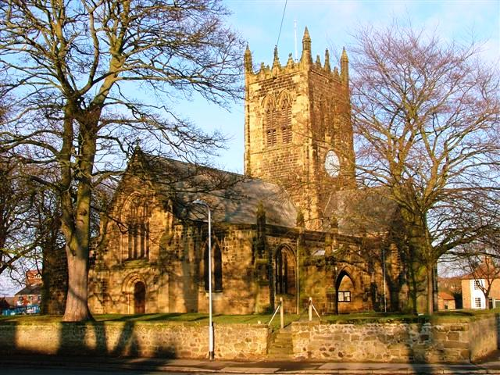

# Scene 16: The Church

The scene happens after the agents pass through the tunnel or find the church by following W.W. Stark. It is hard to image the agents leaving the church intact. The nightgaughs will set off a gleeful attack on the agents and this will likely cause the agents to wreck the church.

Pages 26-31. The Director will likely have to just go with what the agents do. The first time they get to the old church they will likely find it not in use. Any action they take trips the murder scene to happen. W.W. Stark moves up the plans.

# Scene 17: The Church for Ambush or Night Meeting

This covers pages 30-32.

If the agents manage to get into a fight at the church then the fight is only with W.W. Stark and his men. If they come at night and get trapped in the basement they should find, after a bit of a scare, the tunnel to the tomb. They can use the gate if they feel really brave or, being agents, they will breakout of the tomb. They will then meet Sherlock Holmes and can enjoy a firefight with W.W. Stark and his men. They will use a gate to escape with a few of the men going down. The Director should try to get W.W. Stark out of harms way. If he is killed he will just be brought back again.

Realms of Cthulhu page 119 for Dark Young.

# Scene 18: The Second Murder

The scene changes to the murder at the main house. If the agents attack W.W. Stark or cause damage to his plans, in our game they blew up the church, then plans move forward to frame Holmes for a murder.

As described on pages 32-34 W.W. Stark has framed Sherrinford by drugging him, murdering Lucinda, and putting the murder weapon on Sherrinford’s hands and disappearing through a gate before the door to Sherrinford’s room can be broken down. It will take no skills to find a chalk mark and rat hole in the room. The gate is destroyed.

It is possible that the agents might guard Sherrinford and prevent the framing. W.W. Stark will just murder Lucinda in her room and leave Sherrinford’s name spelled in the blood of the dying woman. Again the signs of a gate, chalk marks and rat hole, will be evident to the agents.

Graves will believe the agents, he already believes in “little people,” but this will be no avail. Sherrinford will be horrified to awaken in yet another murder. He will be put to bed and well guarded. Dr. Sacker and Constable Culverton are sent for and Sherrinford taken and brought to the gaol.

Text of Sherrinford’s memory of the event should be shared with players.

W.W. Stark and his men will not likely be there. Jevers has a letter that is a resignation of the W.W. Stark and his men stating that “event” prevent him from working there anymore.

# Scene 19: A Shot

The agents are given a day to investigate and to consider their actions. They may send an appeal to Mycroft. They may want to explore and try to find out any additional information. W.W. Stark has set up an assassin to take a shot at the agents with a rifle near the house. The assassin is well hidden. The first shot will miss allowing for a bit of movie-style suspense. The assassin is from Dr. Moriarty’s crime organization and was hired to “solve” a small problem of the agents. The agent has a horse nearby and will try to escape.

*The air is suddenly very still and the birds stop chirping. A crack and dirt flies up as a bullet nearly misses you. Someone with a rifle is trying to kill you! You cannot see the shooter.*

The shooter is behind a blind and has very good cover in some natural area by some hills, -4 to Shooting, and hard to spot, -2 to Notice. The shooter will aim for one round this time (for +2). The assassin is set-up at a distance of 30 from the agents, -2 to Shooting. If threatened he will run to his horse, nearby, and try to get away. He has no papers on him other than some sketches of the agents and a hundred Pounds in currency. If captured he will just ignore the agents knowing that Dr. Moriarty’s agents will rescue him some time in the future. He is just a paid assassin and receives his missions in writing with sketches of this “clients.”

The rifle is highly illegal in England. No ammunition will be found in the area for it. The agents may wish to use it and so the number of shots remaining may have to be carefully accounted for.

**Enemy Assassin**

**Attributes:** Agility d8, Smarts d6, Spirit d6, Strength d6, Vigor d6

**Skills:** Climbing d4, Fighting d6, Healing d4, Intimidation d4, Investigation d4, Notice d4, Riding d4, Persuasion d4, Repair d4, Shooting d10, Stealth d4, Streetwise d4

**Charisma:** --; **Pace:** 6; **Parry** 5; **Toughness** 6

**Hindrance:** Wanted (major), Obligation to Moriarty

**Edges:** Brawny, Quick

**Languages:**English, German, French, Spanish

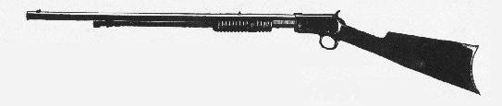**Gear & Equipment:**

Winchester 1890 Rifle[22]: Range 24/48/96, Damage: 2d6, RoF: 1, Weight: 5, Shots: 8, Min Str: d6, Notes: AP1.

The assassin has a box of 20 bullets and thus can reload quite a few times. It takes two whole round to reload.

Survival knife; Damage d6+d4 (+1 on Survival rolls)

# Scene 20: Attack at house

The agents are not left unmolested at Mycroft Manner. W.W. Stark sends more followers to attack those in the house. He wants the agents gone. The attackers are after the agents and now to ignore anyone but Graves. Graves by now is clearly on the agents side.

The followers enter the house through a new gate either in the attic or basement depending on if the agents are guarding the basement.

The men are strong and nearly fearless. W.W. Stark is not there to help them. They are just to kill the outsiders, the agents. They will use martial arts and close in combat. There are as many attackers as there are agents in the first round. Half as many appear again for the next two rounds. This should be a chance for the players to use all of those powers and weapons they always wanted to use and point out that bring martial arts to a gun fight has an expected results.

*Suddenly a group of angry men charge from a room in the house. More are coming, you can hear them yelling. They spot you and charge in and appear to be taking a martial arts stance.*

## The Attacking Followers

They are dressed as farmer workers and work men. They are strong and not too smart. They speak with an English accent with a slight strange accent that cannot be placed.

Any follower that falls suddenly is engulfed in a cloud of darkness. They have sworn their souls and life to a dark force and it takes them when they fall. Thus when the battle is over there will be blood, bullet holes—or worse, and no bodies.

**Attributes:** Agility d6, Smarts d6, Spirit d8, Strength d8, Vigor d8

**Skills:** Fighting d8, Notice d4, Shooting d4

**Charisma:** --; **Pace:** 6; **Parry** 5; **Toughness** 7

**Hindrance:** Delusional

**Edges:** Brawny, Brawler, Combat Reflexes, Martial Artist

**Languages:**English

**Gear & Equipment:**

Kick: 1d8+1d4+2

Knife: d4+d4.

+2 to recover from Shaken.

# Scene 21: Mycroft

A horse is heard coming and Jevers bring a telegram to the adventurers from Mycroft Holmes. Just a few words: “Coming next train stop Mycroft.” He is kidnapped on the train and hassled off the train before reaching North Riding. He will be drugged and brought to Stonehenge later.

This covers pages 35-36.

# Scene 22: Baker Street

The players receive a telegraph delivered again by Jevers from a horseman. Dr. Watson is coming to help. He will expect them to meet him at the train. He does not plan to go the way of Mycroft and he makes it to players. He meets and talks to the agents and asks them for a summary of what has happened and what their plans are. He discovers a note in his pocket and shares it with the agents. He also tries to make some deductions that are more of the obvious nature. He will also say that if he believed in the occult he would be much more afraid. Lucky, he believes there is a medical and scientific answer for all that is happening.

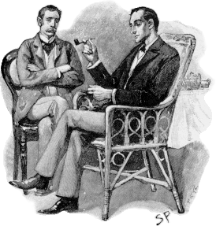Dr. Watson will treat and of the injured agents and generally be helpful.

Though not in the original order, this covers page 36.

## John H. Watson, MD (Wildcard)

See page 46 in original[23].

**Attributes:** Agility d6, Smarts d8, Spirit d8, Strength d8, Vigor d8

**Skills:** Driving (Carriage) d8, Fighting d8, Healing d12, Investigation d6, Notice d6, Knowledge (History) d6, Knowledge (Law) d6, Knowledge (Pharmacy) d12, Knowledge (Psychoanalysis) d4, Knowledge (Psychology) d8, Knowledge (Zoology) d6, Persuasion d6, Riding d8, Shooting d12, Stealth d6, Swim d8, Throw d6

**Charisma:** +2; **Pace:** 6; **Parry** 6; **Toughness** 6

**Hindrance:** Code of Honor, Heroic

**Edges:** Brave, Attractive

**Languages:**English, French, German, Latin, Greek

**Gear & Equipment:**

Webley .455 Service Revolver[24]; Range: 12/24/48; Damage: 2d6; RoF: 1; Shots: 6, Notes: AP1.

Medical Bag (+2 to heal checks)

+2 versus Fear

# Scene 23: The Third Murder

This corresponds to page 34; the material is being reordered a bit. Mrs. Hooper is murdered in her room as described in the text. The chalk marks and newly chewed rat hole are hallmarks of the magical murder. As Dr. Watson is looking at the body Constable Culverton appears at the house. He is looking for Sherrinford who escaped again. He will notice the shock of the agents and folks at the house and guesses that they had nothing to do with the escape. The constable is horrifed that another murder is a locked room has occurred. The window was found open. Constable Culverton looks heart-broken as he tells the agents that Sherrinford must be trying to cover his tracks. “What secret Mrs. Hooper knew about the previous murders, Sherrinford had forever silenced,” he says gravely. The agents and Graves may argue all they want, Constable Culverton is no unfriendly and not willing to listen to the agents or anyone else. Sherrinford will hang for the murders he is sure and the best thing to do is to just get the sordid affair closed as fast as possible. The Constable leaves. Doctor Sachs comes for the body and is never seen again nor is the body. The Dark Young destroys them both before the agents meet it.

# Scene 24: The Trap

The good doctor makes tea for everyone, Mrs. Hooper is gone, and they meet to discuss what actions to take now. They hear a horse approach and Jevers goes out to get another telegraph. There is a shout and then the horse is heard to be running fast away.

This is a version of “Stark’s Return” on pages 36-37. “Scottland Yard Arrives,” page 37 will not be used as it creates too many NPCs for play. The Director can decide to add them in if he or she wishes. It just seems too many for the setting.

*“Jevers! They have kidnapped him!” exclaims the doctor. The doctor has spotted the horseman, W.W. Stark, carrying an unconscious Jever on the back of the horse. He runs out and grabs a horse from Graves and gives chase. “The game is afoot,” he yells as he rides off.*

Graves can have horses ready in a few minutes for the agents. They can ride after Dr. Watson. They find him at a bend and lying on the ground.

*Doctor Watson is hurt and on the ground, “Horse shied when this Stark fellow shot at me,” you notice that there is blood. “I am shot in the arm, just a light injury that I tied off myself,” he says with some pride. “I believe I the fall and the wound were enough to make me swoon and here you found me,” he says with just a hint of embarrassment. “I was in the infantry in Afghanistan, but usually I could keep a horse under me,” he says with conviction. “Yes! Chase after that criminal,” he tells them. “I will find my horse and follow soon,” he orders. “Graves, please give me a hand. Go, Graves can help me,” he says as if back in the military. Graves had appeared on horse back. “Go, I’ll take care of the doctor,” says Graves as he points you to head down the road.*

As this is going on Jevers has been sacrificed to raise a Dark Young in the trees. It will be waiting for the agents. Their horses will throw them or bolt and leave them to face it. The riders will have to make a Ride check to not be thrown from the horse. Anyone who is thrown must make vigor roll or become fatigued by the fall. A benny can be used to avoid this condition—the players should be informed of that if one of the agents becomes fatigued from a fall. It is assumed that the agents follow.

Assume a road and horses with a forest.

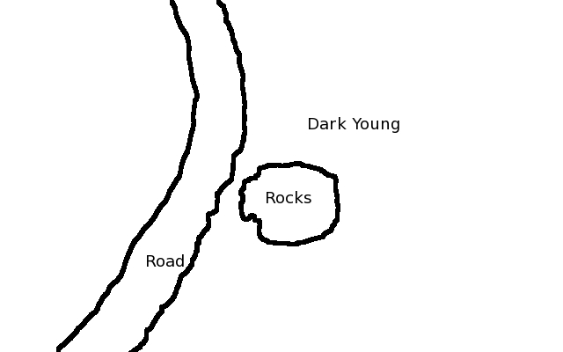

*As you ride around a bend in the road you see a small pile of rocks. The rocks are covered with a dark substance, likely blood and a tree near the rocks suddenly lurches towards you. Some eldritch horror has been summoned and set upon you. A few shots from guns and you learn that it just ignores the bullets—this looks like some horror that requires an axe. Your horses are too nervous and you dismount. W.W. Stark has left you with a Dark Young to deal with.*

The Dark Young tactics is to close and drain the agents and then eat them. It is not very complex in it “thinking.” Eat them! The agents can out run it on horseback. They can fight it. They can play a game of keep away as they use whatever resources they have that can affect it: It is immune to guns and explosives. The battle could be bad for the agents.

Realms of Cthulhu page 119 for Dark Young.

When the battle is ended Graves and a bandaged Dr. Watson follow on horses. They meet the agents about the same time the reach the church.

# Scene 25: The Gates

They see W.W. Stark just finishing a spell to open a gate into another world and leaps through. The agents need to follow. This part of the adventure is much changed from the text. It is designed to allow for a more likely outcome in favor of the agents. This co

*As you see the church you also see W.W. Stark waving his hands in a manic way. Stabbing here and there as fast as he can over and over while chanting words in a language that you do not understand, but the words create a feeling of unease and yet also yearning to see distant lands. A shimmering circle forms and the hint of night and a sky of stars you do not recognize appear in the circle of energy that floats in the air. “Follow if you wish to learn the fates of the Holmes brothers,” he yells and laughs as he calmly walks into the circle. You hear from the circle W.W. Stark’s voice, “Of course we should make this a bit more of a challenge—here my pretties have them.”*

*A pair of monstrosities fly out of the circle, they barely fit. The pause to look and their wings look to small to hold them up. Giant twisted versions of serpents with extra tentacles popping in and out of their sides in a rhythm with their wings. The smell is of rot and marigolds. They attack!*

The two creatures attack and fight to the end. When slain they just melt to slime and evaporate. They will focus on the agents and ignore the Graves and the Doctor. The doctor tries to shoot with his left hand and misses. Graves protects the doctor and manages to force the creatures away with an axe. The axe was last used by W.W. Stark and the Things smell him on it and fly away from it. It is not magical and after the battle the axe will not have much more use other than as an axe.

*Graves and Doctor Watson head for the gate and says to you, “Time to end this—and I take back anything I said about the occult have scientific explanation.” He heads into the gate, “Once more into the breach, eh Graves!” is the last words you hear.*

## More Things[25]

Flying winged giant serpent like creatures that have extra tentacles popping in and out of their sides.

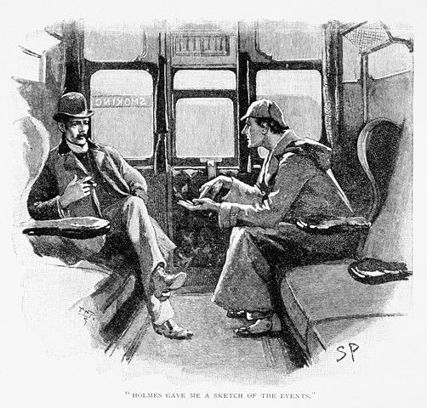**Attributes:** Agility d6, Smarts d4, Spirit d6, Strength d12+2, Vigor d12+2

**Skills:** Fighting d6, Notice d4

**Charisma:** --; **Pace:** 8; **Parry** 5; **Toughness** 9

**Languages:**English and eldritch languages

**Special Abilities**

* **Bite:** d12+d8+2
* **Armor +1:** Extra think skin

**[26]**

# Scene 26: Holmes

The scene changes to another time and another earth far in the past. It is now time to face the final battle not on earth of 1890 but one much newer. The standing stones of Stonehenge are now new and standing in a new pattern, not the one seen today or even in 1890. The Director is thus able to build a model as he or she wishes or try to draw it or use a completely different set. There are many evil temple sets out there.

The agents arrive and find a dark scene of night long ago in England.

*The area smell of ozone and a storm is building and there is a flash. The stars are quickly disappearing as if some terrible dark force is consuming the universe. Another flash and you see the body of W.W. Stark lying on the ground bleeding out. You hear Doctor Watson near a stone. Sherlock Holmes is sitting up against the rock and Doctor Watson is apparently caring for him. “Sherlock is serious wounded,” he yells to you over the thunder. Sherlock see you and smiles, “My best agents!” He turns to you as Doctor Watson continues to remove his shirt and bind long cuts from a knife fight, “I do not believe you are really part of our story and I find no record of you before this affair. I still trust you—I just believe you are here to bring this to a close.” He shakes his head, “Me, trapped in an occult story like this—I must make some apologies to some in the future.” He suddenly looks concerned after a loud crash, “We cannot fight as we are—rescue my brothers. Leave Moriarty to the things of this world—he has likely purchased power at some cost. I doubt he can pay if my brothers are saved.” He hands you a black tea box. “Throw this on my brothers and they will return to their time and place.” He winces as Doctor Watson closes a wound and comments on the fine work the doctor is doing. “Colonel Moran may be Moriarty’s man but he fears this and he gave me some aid and this powder,” his eyes are shinning with the irony. “Yes, Professor James Moriarty found the only thing that would scare his best man into my arms: Eldritch horrors,” he waves his hand at the sky.*

*Sherlock hand you a book, a copy of the stories you saw in library that started this. “Interesting reading and fiction according to the library card by some Doyle,” he says with a laugh that causes him to wince and make more suggestions that Doctor Watson needs more practice. “Don’t open it until you are finished—it is a very nice library—but I think we should finish this story first,” he says with very serious eyes. Doctor Watson turns to you and whispers, “Graves and I need to get him to a hospital and better care.” He looks grave. “Just throw a pinch of the powder from the box on us now and we’ll leave you to finish-up,” says Holmes with a smile.*

The Director does not want to put Watson and Holmes or all the other characters in the final battle. It is up to the agents to end this. Any creature that is not from this time or place, except for the agents, will be sent back to their home and time if hit with the powder. It is a Throw check to hit someone with it. The agents can use it instead of weapons to deal with some of the bad guys.

# Scene 27: Stonehenge and the Final Battle

The scene is of Stonehenge in the distant past. There are cultists, transformed now into hybrid humans now, are dancing and chanting. Moriarty, Nyarlanthotep, and Sherrinford are standing over an unconscious Mycroft in a white robe lying on a slaughter stone. Moriarty has promised the souls of the Holmes brothers to his protector and teacher, Nyarlanthotep, as payment for all he has learned and done. Nyarlanthotep is aware of the agents and Sherlock’s actions. It amuses the god to have opposing groups fight it out. It will not interfere. The figures should be set-up as if the player’s agents are about to close in on the cultists, Holmes brothers, Nyarlanthotep, and Moriarty. There should be two cultists for every agent.

*The thunder is louder. You can see Moriarty, in black and looking like a likeable professor watching some natives dance, standing with a tall man who is dressed in a military uniform you do not know, Sherrinford is standing next to Mycroft lying on a stone. The Holmes brothers look drugged. The “natives” are devolved humans that are chanting. They are now covered with scales and have claws and fangs. A few sport the remains of a tie or other dress. Not long ago they were still human!*

*Before you can take any action the tall man in the uniform turns to you and looks you in the eye—even from so far away. All of you think he is looking into your eyes alone. You see in the eyes the stars and swirls of universes. You feel like you are falling. That you no longer exist and are just a piece of dust in the create wheel of dust. You can “taste” color and feel radiation and burn in the heat of no heat in cold space. You “hear” a flute playing an insane.*

*You are back where you were. All is silent. There is flash of light and the area is bright and each of you is lighted up in some strange way. The man in the uniform is gone. Moriarty see what has happened, smiles, “Kill the unbelievers, I have always wanted to say that,” he yells and points at you. The cultists attack.*

This is an image of Stonehenge in the 1890s[27]:

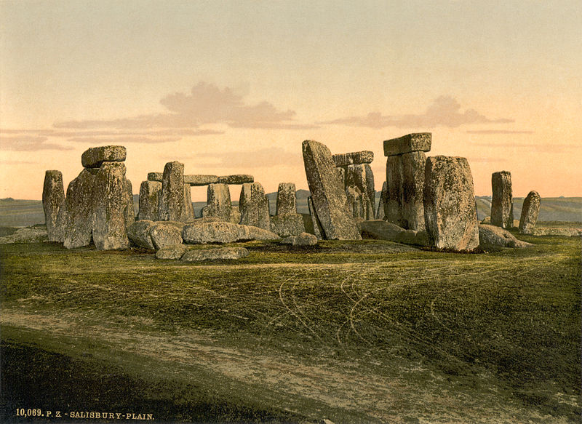

Map of Stonehenge[28]:

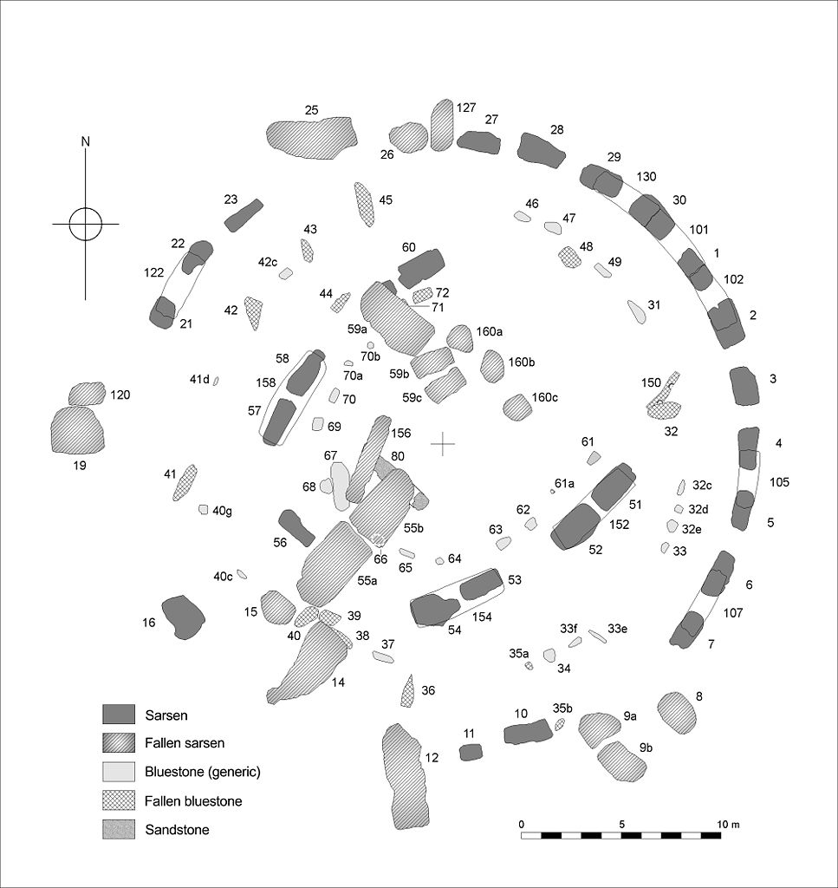

The battle continues. Professor James Moriarty will stay low and behind stones. This gives him +6 against any ranged attacks. He also believes that he has Powder of Return and thus can escape. When it is sure that he has lost he will try to escape. This item was replaced by his very own Colonel Sebastian Moran who allied with Sherlock Holmes against Moriarty once he began to dabble in “things that man is not meant to know” and left crime behind. His small container is empty. When he tries to escape he will learn of the betrayal, He screams out Moran’s name:

*Moriarty screams out one name, “Moran!” All is suddenly silent again. A small whisper is now heard, “Moriarty, there is no leaving without payment,” and is heard by everyone. Moriarty face is white with fear. “No fear Professor, join me in the dark and be remembered, it is a bitter fate for a man like you—but come and we will see all the darkness.” Moriarty just disappears. “Return to your story agents,” is the last words heard. The entire cultists start to dance a strange dance to a strange flute like sound and in each whirl of the dance they devolve more. Soon they are small animals, then slime, and then nothing.*

Note: If Moriarty is wounded instead then make some revisions but try to follow the same line.

The battle is done once Moriarty tries to escape.

## The Cultist

See page 42 in original. These are changed to have claws and look sub-human with large teeth and claws. Some have huge eyes while others large teeth. Some still wear remnants of modern clothing. They have devolved here in this time.

**Attributes:** Agility d6, Smarts d6, Spirit d8, Strength d8, Vigor d10

**Skills:** Fighting d8, Notice d4, Shooting d4

**Charisma:** --; **Pace:** 6; **Parry** 5; **Toughness** 8

**Hindrance:** Delusional, Hybrid

**Edges:** Brawny, Brawler, Combat Reflexes, Martial Artist, Moniker: Henchmen, Hybrid

**Languages:**English

**Gear & Equipment:**

Kick: 1d8+1d4+1d6+2

Bite: 1d6+2 (for poison)

Crude Knife: d4+1.

+3 to recover from Shaken (+2 if not in sight of Moriarty).

Uses Wild Die as Henchmen.

## Professor James Moriarty (Wildcard)

See page 47 in original.

**Attributes:** Agility d8, Smarts d12+1, Spirit d12, Strength d8, Vigor d8

**Skills:** Fighting d10, Healing d4, Investigation d10, Notice d8, Knowledge (Anthropology) d8, Knowledge (Archaeology) d6, Knowledge (Chemistry) d10, Knowledge (Crime/Criminology) d12+2 (Master), Knowledge (History) d4, Knowledge (Law) d6, Knowledge (Mathematics) d12+2 (Master), Knowledge (Mechanics) d10, Knowledge (Occult) d10, Knowledge (Physics) d12+2 (Master), Knowledge (Psychology) d10, Lockpicking d12, Persuasion d10, Repair d10, Riding d4, Shooting d8, Stealth d6, Throw d4, Track d8

**Charisma:** +2; **Pace:** 6; **Parry** 7; **Toughness** 6

**Hindrance:** Wanted (Major), Insane

**Edges:** Brave, Master x3, Lucky, Charismatic, Command, Followers, Mythos Based Caster

**Languages:**English, French, German, Latin, Greek

**Gear & Equipment:**

Sword Cane: Damage d4+d8

.38 Revolver; Range: 12/24/48; Damage: 2d6; RoF: 1; Shots: 6, Notes: AP1, Revolver.

+2 against Fear, extra Benny.

Empty box that is suppose to contain Powder of Return.

Spells: Contact Nyarlathotep, Create Limbo Gate, Create Powder of Return

## Spells

*Create Powder of Return:* This spell is performed over the burned remains of an important Mythos book. It must be totally burned to ashes. The caster then invests six power points to imbue the return power to the ashes. If the ashes are thrown and make contact, Throw check, with a creature not in its time or home place it immediately disappears and reappears at its home and its home time.

# Scene 28: Back to the Library

The agents open the book that Sherlock Holmes gave them and suddenly they appear back in the library. Mr. Rogers is waiting outside.

*You are back in the library. The book is one of your hands and you see that you are reading the inscription, “1896, April 30, Bakers Street: Thanks to my best agents! SH” There is also a signature of Sir Conan Doyle with no comment. “Your story may continue, N” is written in a dark darkest ink that seems to send up on the page as if poured on then written. Some strange symbols and writing are also on the page but appear to becoming lighter. Mr. Fred Rogers, the librarian, comes in and looks at the inside cover. “The strange symbols are more faded than last time I saw them,” he says to nobody in particular. “False alarm,” he says with relief in his voice. “Since this was a waste of time, can I introduce you to a new product we are producing here, we are calling it ‘micro-brewing’,” he waves you out as he says this and puts the book back on the shelf. “A couple of the students have found a process that makes a good beer from local ingredients,” he says with a bit of anticipation in his voice. “It is quite good,” but the name is funny, “Moriarty Dark. It is a bitter brew but with some surprising hightlights.”*

Forward 1

The Hook 2

Notes to The Director 3

Revised Magical System 3

The Briefing 4

The Mission Profile 4

Scene 01: The Library 5

Scene 02: 1896 London 5

Scene 03: Train to North Riding, Northallerton 10

Scene 04: Northallerton 11

Scene 05: Meet Police 12

Scene 06: Meet Sherrinford 13

Scene 07: Mycroft Manor 13

Sherrinford Holmes’ Study 13

Conservatory/Greenhouse 13

Game Room 14

Foyer 14

Pantry 14

Kitchen 14

Jever’s Room 15

Lucinda’s Room 15

The Hired Men’s Room 15

Utility Building 15

Master Bedroom 15

Attic 15

Basement 16

Rat-Things in house 16

Sherrinford Holmes (Wildcard) 16

Graves 17

Jevers 17

Mrs. Hooper 18

Lucinda Jones 18

W.W. Stark (Wildcard) 19

The Hired Men 19

Scene 08: Workingmen 20

Scene 09: Surrounding Areas (No combat) 21

Transportation 21

Tenant Farms 21

Scene 10: Standing Stones 21

Things 21

Scene 11: Old Eban 22

Old Eban (Wildcard) 22

Scene 12: Northallerton Constabulary 23

Scene 13: The Red Rooster Inn 23

Scene 14: North Riding County Archivist 23

Scene 15: Northallerton Anglican Church 24

Scene 16: The Church 25

Scene 17: The Church for Ambush or Night Meeting 25

Scene 18: The Second Murder 25

Scene 19: A Shot 26

Scene 20: Attack at house 27

The Attacking Followers 27

Scene 21: Mycroft 28

Scene 22: Baker Street 28

John H. Watson, MD (Wildcard) 28

Scene 23: The Third Murder 29

Scene 24: The Trap 29

Scene 25: The Gates 30

More Things 31

Scene 26: Holmes 31

Scene 27: Stonehenge and the Final Battle 32

The Cultist 35

Professor James Moriarty (Wildcard) 35

Spells 36

Scene 28: Back to the Library 36

*The Cthulhu by Gaslight: The Yorkshire Horrors* is copyright 1986 by William A. Barton; all rights reserved.

This work contains original material based on the copyrighted material and is not to be used for profit, personal or corporate. The author makes no claim to this work or the original work. This was just for fun!

1. A fine product from Chaosium, Inc. and this writing while based on their work is meant to update their adventure to a new system. No rights are claimed by the author to any of this writing, it is a pleasure to play this adventure in a new setting.
2. *Savage Worlds* is a great gaming product from Pinnacle Entertainment Group and they have not approved this writing nor does the author intend in anyway to conflicts with their rights and copyright. He just wants to play the game with more material that he wrote.
3. *Agents of Oblivion* is also a great gaming product from Reality Blurs, LLC. and this writing is also not approved by them nor does the author of this document intend in anyway to conflict with their rights or copyright. The author’s intent is to write more material to play the game in his campaign.
4. This image is in the public domain: <http://en.wikipedia.org/wiki/File:Sherlock_Holmes_Portrait_Paget.jpg> .
5. Realms of Cthulhu is another great gaming product from Reality Blurs, LCC. It is a setting for *Savage Worlds* and is even approved by Chaosium, Inc!
6. See [www.alangodfremaps.co.uk](http://www.alangodfremaps.co.uk) .
7. You can get a summary of weather by month <http://www.metoffice.gov.uk/media/pdf/2/i/Apr1896.pdf> .
8. See SW rules on Hazards
9. <http://en.wikipedia.org/wiki/Hounds_of_Tindalos> .
10. The Director may use Arkham Now as a source book for short part of the mission. This is not needed for this scene.
11. From page 19. Revised to not show any extra information.
12. From page 10. Revised to show only information known to players.
13. Image is in public domain <http://en.wikipedia.org/wiki/File:Kings_Cross_ILN_1852.jpg> .
14. Image is in public domain

    <http://en.wikipedia.org/wiki/File:NorthRidingofYorkshireCOA.png> .
15. David Rogers [CC-BY-SA-2.0 (http://creativecommons.org/licenses/by-sa/2.0)], via Wikimedia Commons
16. Image is from <http://en.wikipedia.org/wiki/File:Illustration_Papaver_somniferum0.jpg> .
17. Mix of original and Realm of Cthulhu creature of the same name.
18. AoO page 19.
19. See SW rules on Poison in Situational Rules.
20. Simplified version from original.
21. Mick Garratt [CC-BY-SA-2.0 (http://creativecommons.org/licenses/by-sa/2.0)], via Wikimedia Commons, <http://commons.wikimedia.org/wiki/File%3AAll_Saints'_Church%2C_Northallerton_-_geograph.org.uk_-_114412.jpg>
22. See for image <http://en.wikipedia.org/wiki/File:Winchester1890.JPG> and <http://en.wikipedia.org/wiki/Winchester_Model_1890> .
23. Images is found here: <http://en.wikipedia.org/wiki/File:Paget_holmes.png> .
24. See http://en.wikipedia.org/wiki/.455_Webley.
25. Simplified version from original—these are repeats of the things by the stones. Too good not to use again.
26. Image from <http://commons.wikimedia.org/wiki/File:Strand_paget.jpg> .
27. Image is in public domain http://en.wikipedia.org/wiki/File:Flickr_-_…trialsanderrors_-_Stonehenge,_Salisbury,_England,_ca._1895.jpg .
28. Image from <http://en.wikipedia.org/wiki/File:Stone_Plan.jpg> .